

Web based System for Public Complain Movement Management System

For

Excise Department of Sri Lanka

S.K.P. Mallawarachchi

BIT Registration Number: R171533

Index Number: 1715331

Client: Department of Excise

Sri Lanka

Name of the supervisor:

Miss. R. M. M. S. Rathnayake

**2019/2020**



**This Evaluation Report is submitted in partial fulfilment of the requirement of the Degree of Bachelor of Information Technology (External) of the University of Colombo School Of Computing**

# DECLARATION

# ABSTRACT

Excise Department of Sri Lanka was established in 1913 and operates under the purview of the Ministry of Finance and Mass Media at present. It holds the third place among the tax income generating Departments to the Government. Excise Department of Sri Lanka mainly implements the Excise Ordinance No.08 of 1912 which is the 52nd Chapter of the Legislative Enactment. Moreover, it implements the Tobacco Tax Act No.8 of 1999, Poisons, Opium and Dangerous Drugs Ordinance and the National Authority on Tobacco & Alcohol Act No.27 of 2006.

Excise Department of Sri Lanka is reputed government company that is dedicated to build a healthy society in Sri Lanka, which is free from illicit liquor and narcotics drugs. Excise Department of Sri Lanka operates under the direction of a Commissioner General of Excise. Public complain management is the one of the main roles of the department. Currently below activities are being done by the department.

* The collection and protection of revenue from Liquor and Tobacco.
* The enforcement of the Excise Ordinance and the Tobacco Tax Act.
* The enforcement of the Poisons, Opium and Dangerous Drugs Ordinance.

Still they use manual system to manage their day-to-day activities. It is very heard to manage large number of record books. They manage number of various types of bills for various types of photo orders and considering about this tedious task, data redundancy has become the main problem in their manual system. Proposed system follows Model View Controller (MVC) architecture and JAVA and PHP is used as programming language with object-oriented design principles. RUP is the design model used for this system. This web-based application is going to be developed using technologies known as XAMPP, MYSQL Database Server is used as Data Base Management System and NetBeans with IntelliJ idea is used as Integrated Development Environments (IDEs).

This public complain movement management system has been designed to full fill not only functional requirement as well as non-functional requirement of users. As well as this system will help form excise guard up to management to work efficiently and without any obstacles which busy working periods and prevent misconsidering of even a single inquiry.

The technology behind the proposed system, Inteli J IDEA is used to implement the system in JAVA, MySQL, Spring & Hibernate technology, MVC architecture with Object Oriented approach. UML as a modeling language to analysis and design the system.

# ACKNOWLEDGMENT

I would like take this space to acknowledge and extend my heartiest gratitude to those who have helped me in different ways throughout the project work to make this project a success.

First and foremost, I owe my deep gratitude to the University of Colombo School of Computing for offering us this precious degree program and all its staff who guided me from the beginning.

A very special recognition should be given to my project supervisor **Miss R.M.M.S. Rathnayake** for the extensive assistance and valuable guidance, if their support is not received the completion of this project would have been extremely complicated.

I also take this opportunity to thank **Mr. H.G. Sumanasinghe** Commissioner General of Excise and **Mr. Buddhika Weragoda** Commissioner of Excise (Admin & HR). Very special thanks, By giving new ideas and providing opportunity to collecting facts for this project **Mr. R.M.Rathnayake** Deputy Commissioner of Excise (Supply Chain Regulation & IT), **Mr. Kapila Kumarasinghe** Deputy Commissioner of Excise (Crime and law Enforcement) and **Mrs. D.H.D. Rupasinghe**Information & Communication Technology Officer. All the excise staff gave me an enormous support to complete the project successfully.

It is my duty to thank **Mr. R.D.D.Suranga** *the Managing director*¸ **Mr. Susith Sanasuma**, *Administrator*, Lecture panel and all the staff at Earth University College, Colombo and Gampaha branches for giving me the academic knowledge for the BIT degree program and allowing me to use the college library throughout the period. Also, I honestly thank all my friends of Earth Institute.

Finally, I thank my family members, *Son, Daughter* and *loving Wife* who gave me unconditional support in every way possible throughout the process of this degree program of past three years.

# TABLE OF CONTENT

DECLARATION ii

ABSTRACT iii

ACKNOWLEDGMENT v

TABLE OF CONTENT vi

LIST OF FIGURES viii

LIST OF TABLES ix

LIST OF ACRONYMS x

CHAPTER 01 – INTRODUCTION 1

1.1 Motivation 1

1.2 Aims & Objective of the Project 1

1.3 Scope of the Project 1

CHAPTER 02 – ANALYSIS 2

2.1 Description of current system using a diagram 2

2.2 Outline of existing similar solutions with references 2

2.3 Requirements 2

2.4 Relevant diagrams for the selected methodology 2

CHAPTER 03 – DESIGN 3

3.1 Alternate solutions evaluation 3

3.2 Selected solution description and justification 3

3.3 Relevant design diagrams 3

3.4 User interface design 3

CHAPTER 04 – IMPLEMENTATION 4

4.1 Implementation environment (hardware/software) 4

4.2 Code and module structure description 4

4.3 Acknowledgement of any reused existing code 4

CHAPTER 05 – EVALUATION 5

5.1 Test plan 5

5.2 Test Result 5

5.3 User Evaluation 5

CHAPTER 06 – CONCLUSION 6

6.1 Critical assessment of Project 6

6.2 Future work 6

REFERENCES 7

APPENDIX 8

# LIST OF FIGURES

# LIST OF TABLES

# LIST OF ACRONYMS

# CHAPTER 01 – INTRODUCTION

## Background

Excise Department of Sri Lanka extends a significant contribution for the task of implementing laws imposed under said ordinances and acts relevant to narcotics and drugs. Similarly, this Department serves as a member of the National Dangerous Drugs Control Board, National Authority on Tobacco & Alcohol for the purpose of implementing government policies while extending a great contribution for achieving the national goal of creating a country devoid of liquor and narcotic drugs under the theme of “A Nation Free of Alcohol” in collaboration with the Presidential Unit on Alcohol Prevention.. They offer following types of major services.

## Motivation for Project

This project is being implemented to full fill the final project of BIT Degree program and the main target was to pass the project module successfully.

Nowadays most organization understand importance of computer-based information system due to large number of advantages like high efficiency, high reliability, easy backing up, easy maintains and many more.

There is a public complain of letter (called it Petition) receive to head office of Excise Department about selling “kasippu” at behind the Panadura Basic Hospital (think as an example). At first take this letter by Excise Guard who is the receiving officer of public complain, write down on “Petition Book” by giving number and relevant information about this petition and forward to Deputy Commissioner of Law Enforcement with opening a file for this case. Then the Deputy Commissioner (DC) reads this petition and put a commanding note on this file and tell to send it to Assistant Commissioner (AC WP-2) of relevant area. Assistant Commissioner reads and order to send it to Superintend of Excise (SE WP-ii) on that relevant area. Then he also reads and order to send it to Office in Charge (OIC Panadura) of Excise station that the petition address is within the area of above Excise Station. According to the petition OIC may decides to arrange a detection team. Head of the detection team who is normally one of the Inspector of Excise in that station. After that the Inspector takes necessary action to this petition under the supervision of OIC, SE, AC.

Accordant to this example, when the petition file goes out from the head office, they don’t know what is the current situation for this petition without telephoning by office to office.

## Aims & Objective of the Project

### 1.3.1 Objective of the Project

1. Real time tracking of at what stage above petition is on.

Proposed Inquiry Movement Management System is a web base system so it can operate from anywhere by authorized persons. Like a traditional file, it has a view called “Minute” When any authorized officer log into this system and get view that reverent inquiry, he can look for what is the current position of the above petition now on, without calling any one.

(2) By using NIC or passport number, a part of name, or even finger print can easily search conviction of the offenders.

Ongoing manual system of conviction of the offenders, it very harder, searching of past convection of suspenders because the manual system can search only the such incident who had done by in this particular area only. Actually, above suspending could be charge by other area’s court the of Sir Lanka, but reverent area officers cannot get information from their usual Offenders Register book

By this proposed web base system, can search any conviction of records at any areas of Sri Lanka, he had done by using NIC number or passport number, a part of name, or even finger print.

1. Accessibility to relevant information for authorize internal &external parties
2. Time wasting and data duplication

(5) Encourage participatory good governance

(6) Customize various report generation

## 1.4 Scope of the Project

Accordant to this example, when the petition file goes out from the head office, they don’t know what is the current situation for this petition without telephoning by office to office.

This proposed system will aid from excise guard up to deputy commissioner of law enforcement by conducting their routine activities as mentioned below.

* Basically, the project scope is to develop a computerize inquiry management system. It has to be developed and manage complete island wide web base solution.
* Provide more function to people to easily put the petition to the Excise department by using e-mails, SMS, social medias such as Facebook.
* Also send inquires to department by using interfaces which are gives to President Security Office, Priminister’s office and Dangerous Drugs Control Bureau providing by this proposed system.
* Island wide where ever can registered a petition with a unique number.
* Advance user-friendly searching option to identify conviction of the offenders.
* Automate the printing relevant court case documents, by only giving the crime number.
* Highly control accessibility of officers by offering more security.

Other Major objective of this project is built up a Computer Based Information System for Department of Excise. In addition, other objectives can be listed as follows.

* + - Improve efficiency of day-to-day transactions
    - Prevent Misuses and miss considered complaints
    - Enclose all the complaint movement process to higher officers at the department
    - Provide security and easy access to the system
    - Improving efficiency of the current process of inquiring for the complainers
    - Reduces usage of futile documents and records
    - Make decisions immediately even without analyzing the complaint detail more for the commissioner general.

## 1.5 Structure of the Dissertation

Chapter 02 – Analysis

This chapter will provide details about analysis phase of system development life cycle. Collected good set of requirement including both functional and nonfunctional requirement are listed in this chapter.

Chapter 03 – Design

After requirement elicitation, design should be done. Details about design phase, diagram which are drawn by us including use case, class, database, activity are drawn in this chapter.

Chapter 04 – implementation

Implementation details will be provided using this chapter. It includes description of major code and module structure, implementation environment including hardware and software.

Chapter 05 – evaluation

Before system is delivered into working environment, it should be tested properly. In this chapter will be discussed about testing techniques, test case and more and also this chapter will prove that proper testing was done.

Chapter 06 – Conclusion

This chapter will conclude the entire dissertation report with the evaluation.

References

All the URLs references and necessary quotations which helped to write this report are contained in this section.

Appendix

# CHAPTER 02 – ANALYSIS

## 2.1 Description of current system using a diagram

Department of excise has been doing their Inquiry Management process manually since they stablished as a department 1912. They record their all details in books. All details about crimes, detections, offenders, fine and court documents are recorded in books and files.

The manual system relies heavily on the actions of people, which increase the possibility of human error. Employees might enter incorrect details.

There are approximately 64 excise stations spread across Sri Lanka to capture illegal liquor trading and related issues. These detections are made by authorized officers and a series of documents have to be originated by them manually with regard to their detections.

The detection officer should enter the all details of the arrested person such as the name of the accused, captured list of productions etc. in a CR (Crime Report). The same details have to be re-entered in a Crime Report book maintained by each station manually.

Also some reports have to be submitted when the accused are presented to the courts. All of these reports are produced manually by the relevant excise officer. Then again the judgments of each law case have to be reported by relevant excise officer of the excise station in a separate book. Mentioned above is a brief description about the process carried out in when a person is arrested.

### 2.1.1 Department structure

Hierarchy of the Department is as follows.

Excise Commissioner General ( ECG )

Excise Commissioner ( EC )

Deputy Commissioner ( DC )

Assistant Commissioner ( AC )

Superintendent ( SE )

Officer In charge ( OIC )

Sergeants Major ( SM )

Sergeants ( SG )

Corporal ( CPR )

Guard ( EG)

Driver ( ED )

### 2.1.2 Users of the system

Basically the heads of each excise station and other authorized personnel are allowed to access to the system. Each user level of the system is mapped with the organizational hierarchy of Department of Excise. However, limitations are developed to control the accessibility to the system according to the ranks of the users in the hierarchy. System functions mainly depend on the organizational hierarchy.

## 2.2 Outline of existing similar solutions with references

### 2.2.1 Similar Systems

#### 

(1) Inquiry Processing, Billing Details Management. System for WaterBoard , Gampaha

Water Board, Gampaha Branch maintain a Computer System for handling Inquiry Processing, Billing Details Management. There are 3 Actors Using their System. They are Manager, Management Assistant, Field Officer. No Computer Operator in their Branch & his part handled by Management Assistant.

Main Window of Inquiry Processing , Billing Details Management at Gampaha

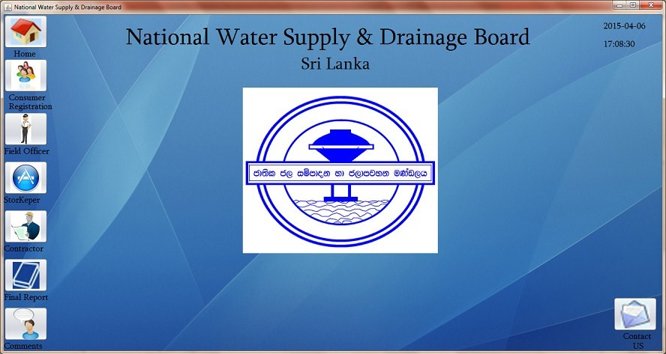

(2) Connection Handling System for WaterBoard , Negambo

Water Board , Negambo Branch maintain a Computer System for handling their New Water Connection & Billing Procedure. There are 5 Actors Using their System. They are Manager, Management Assistant, Field Officer, Computer Operator and Engineers. A few of the abilities the software will give you are the ability to monitor and reports.

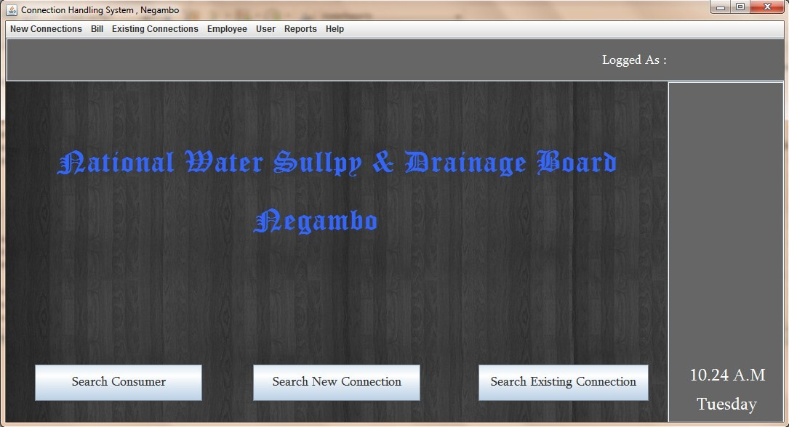

### 2.2.2 Comparison in between existing systems

shows comparison in between existing systems

|  |  |  |  |
| --- | --- | --- | --- |
| Features Software | Inquiry Processing , Billing Details Management system | Inquiry and Connection Handling System | Public Complain Movement Management system√√ |
| Manage complain | √ | √ | √ |
| Manage customer details | √ | √ | × |
| Manage searching facility | √ | √ | √ |
| Manage disconnection schedule | × | √ | × |
| Manage employee details | √ | √ | √ |
| Report generating | √ | √ | √ |
| Notifications | √ | √ | √ |
| User Friendliness | √ | √ | √ |
| User guidance | × | × | √ |
| Manage backup | √ | √ | √ |

## 2.3 Requirements

### 2.3.1 Functional requirement of the system.

Functional requirement describes the requirement or services that system should offer for its end users. Most of them are provided by users of the system. Because this project is constructed according to discipline of RUP process model, most critical requirements are selected for the first iteration of development life cycle. Below list shows functional requirement gathered up to now.

1. Registering petition any time anywhere.
2. Keep the offender’s details and use to identify conviction of the offenders.
3. Managing crime details for generate court document instant.
4. Monitoring of process of petition
5. Manage employee details
6. Manage customer details
7. Generates reports
8. Manage privileges of employees

### 2.3.2 Nonfunctional requirement of the system

Nonfunctional requirement describes the features that system should have. It is very difficult to manage nonfunctional requirement than functional requirement because each user have different perspectives. Nonfunctional requirement which hope to offer with proposed system are listed below.

1. User friendliness
2. Interoperability with other software
3. Accuracy
4. Maintainability
5. Security
6. Usability
7. Simplicity

## 2.4 Relevant diagrams for the selected methodology

### 2.4.1 Software Process & Process Model.

We can simply define, software process is a set of ordered tasks involving activities, constraints and resources that produce a software system. Furthermore, it is important to go through a series of steps to produce high quality software. These steps or the road map followed is called the software process.

#### 2.4.1.1 Software Process.

**Why process is important?**

* It imposes consistency and structure on a set of activities.
* It guides our actions by allowing us to examine, understand, control and improve the activities that comprise the process.
* The process of building a product is sometime called a lifecycle because it describes the life of that.
* product from conception through to its implementation, delivery, use and maintenance. Generic activities in all software processes are,
* Specification - what the system should do and its development constraints.
* Development - production of the software system.
* Validation- checking that the software is what the customer wants.
* Evolution- changing the software in response to changing demands

#### 2.4.1.2 Software Process Models.

A software process model is a simplified representation of a software process. Each process models represents a process from a particular perspective, and thus provides only partial information about that process. For example, a process activity model shows the activities and their sequence but may not show the roles of the people involved in these activities.

**Why is it needed to model a process?**

* When a team writes down a description of its development process it forms a common understanding of the activities, resources and constraints involved in software development.
* Creating a process model helps the team find inconsistencies, redundancies and commissions in the process, as these problems are noted and corrected the process becomes more effective.
* The model reflects the goals of development and shows explicitly how the product characteristics are to be achieved.
* Each development is different and a process has to be tailored for different situations, the model helps people to understand these differences.

Following list give some of the widely discussed process models in the software engineering industry.

* Waterfall
* Prototyping
* Iterative development
* Spiral development
* Rational Unified Process (RUP)
* Agile Methods
* Rapid Application Development (RAD)
* Extreme Programming (XP)
* Agile Unified Process (AUP)
* Scrum.

### 2.4.2 Process Model for the proposed system.

**Scrum.**

Scrum is an agile framework for developing innovative product and services and one of the most widely used process model. With an agile approach, you begin by creating a product backlog which means some sort of SRS (software requirement specification), a prioritized list of the features and other capabilities needed to develop a successful product). Following figure 2.2 will helps to get at a glance idea about scrum model.

Scrum is an agile framework for organizing and managing work and simple, people-centric framework based on the values of honesty, openness, courage, respect, focus, trust, empowerment, and collaboration. Mainly scrum favor to time box development. Main concepts of scrum framework are listed below in nut

## Hhhhhhhhhhhhhhhhh

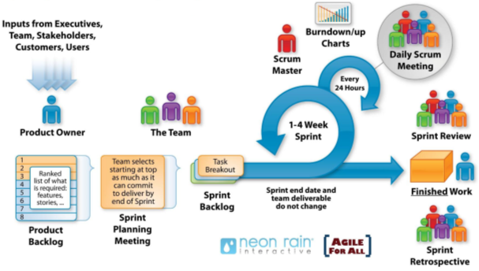

**Main roles**

* Product owner
* Scrum master
* Development team with T shape skills

**Activities**

* Sprint
* Sprint planning
* Daily scrum
* Sprint execution
* Sprint review
* Sprint retrospective
* Product backlog grooming

**Artifacts**

* Product backlog
* Sprint backlog
* Potentially shippable product increment

**Scrum Phases**

* Pre-game
* Sprint
* Post-game

# CHAPTER 03 – DESIGN

In the System Development Life Cycle (SDLC), We’ll discuss about alternative solution, design diagram such as use case, class, sequence.

## 3.1 Alternate solutions evaluation

So many software development process model and design pattern in the world. Among them we should have to select one for our project. In the same time, we have to choose whether the system may either be stand alone or web based system. For this system web based type is selected. Because Excise Department has 106 sub offices. All the employees of the department work throughout these offices.

So, main alternative solution is web based solution. It explains the system working distributed environment with the help of internet including some additional recourses such as web servers, routers, bridges, network cables and etc. This types of solutions are more complicated than stand-alone solution.

## 3.2 Selected solution description and justification

### 3.2.1 Major Reason for choosing Web based System

* Excise department’s AC, SE, OIC, offices must be link with Public Complain Management System `at once. So it must have a Web Base System.
* All these offices have internet connectivity and one or more newly brought P/C machines.
* The Department has high speed consistent internet connection throughout the whole time without any disturbance
* Can perform much faster

## 3.3 Relevant design diagrams

Modelling could simplify the complexity seen in real world system. Drawing diagram will help analyst, designer and developers to communicate what are the needs? And how the system is to build?

Followings are some of the widely used design diagrams.

* UML Diagram
* DFD (Data Flow Model Diagram)
* Program Structure Diagram
* ER (Entity Relationship Diagram)
* Application Flow Chart

UML diagrams are used to model application program in object-oriented approach while DFD, Structure Chart are used in structured approach. Flow charts are used to model the business logic of a process, more formally the algorithm of a function. EER diagrams are used to design databases. Grid chart map application programs with data sources.

The Unified Modeling Language (UML) is a set modeling diagrams that let the designers to see the same system in multiple dimension. Graphical symbols used in UML improve understandability between designers and developers. It is a flexible tool that let practitioners to add their own concepts using the mechanism called stereotyping.

UML has 14 design diagrams and 4 of them have used to design this project.

* Use case diagram
* Class diagram
* Activity diagram
* Sequence diagram

### 3.3.1. Use Case Diagram

Use case diagram can be used to get the idea about users and their duties. In this case user may be human or another system. But in this system there are no another system acting as user so most of the time user is human user. When system is about to be build it is highly needed to identify that who the users are and their duties, they hope to perform on proposed system because we have to offer their requirement to offer via proposed system.

Users of the system

* Receiving Excise Guard
* Deputy commissioner of law enforcement
* Officer in Charge
* Inspector of excise or Sargent major

Use case diagram for receiving Excise Guard and Deputy Commissioner of law enforcement

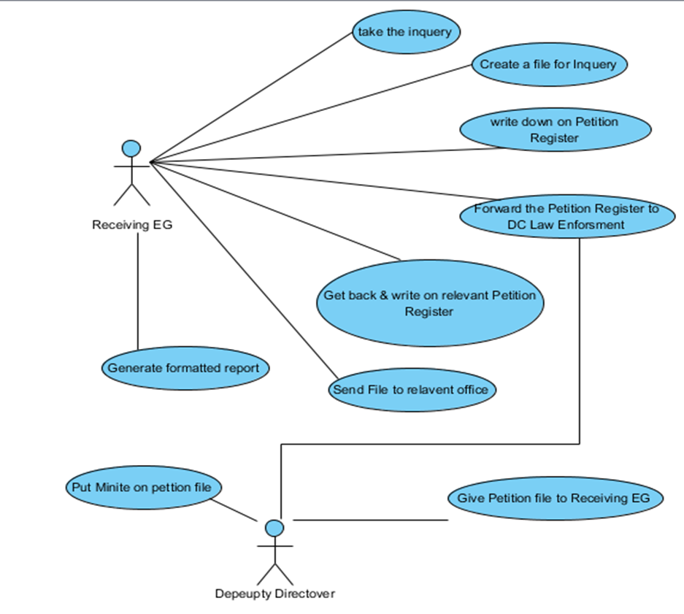

Use case diagram for Officer in Charge

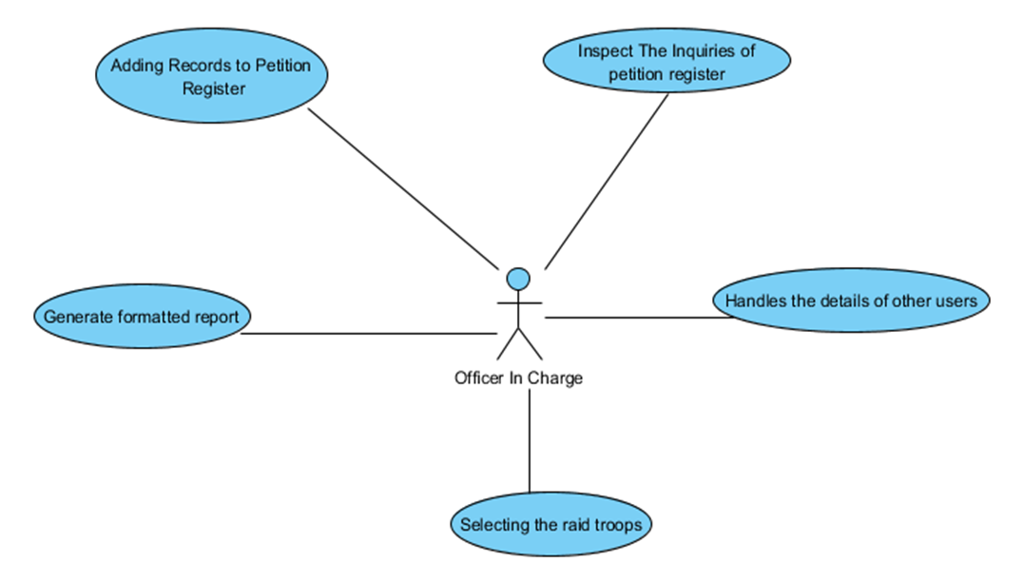

Use case diagram for Inspector or Sargent major or Sargent of Department of Excise

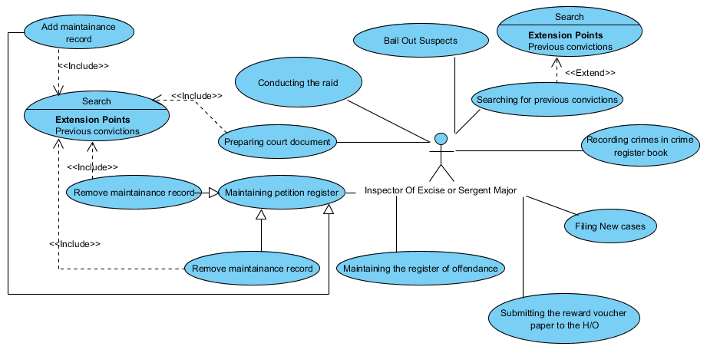

*Use Case description for* takeover the inquiry

|  |  |
| --- | --- |
| Use case | Takeover the Inquiry |
| Actor/s | Receiving EG |
| Description | Register an inquiry |
| Precondition | 1. Receiving EG log in to the system 2. Details of inquiry should be added |
| Flow of event | 1. Type number for inquiry 2. Select or write other details of the inquiry 3. Press Add button to register new inquiry |
| Post condition | Forward it to DC Law Enforcement |

Use Case description for raid troop selection

|  |  |
| --- | --- |
| Use case | Raid Troop Selection |
| Actor/s | Officer in Charge - OIC |
| Description | Selecting a raid troop |
| Precondition | 1. OIC log in to the system 2. Suitable employees should be added |
| Flow of event | 1. Select the inquiry number 2. Enter employees who works above office 3. Press Add button to create new raid troop |
| Post condition | Inform to relevant inspector |

Use Case description for Minit selection

|  |  |
| --- | --- |
| Use case | Minit on selected file |
| Actor/s | Deputy Director |
| Description | Put a minit on selected file |
| Precondition | 1. File must be filed by the excise guard (EG) 2. Director must be logged into the system |
| Flow of event | 1. Take over the file 2. Inspect the case 3. Insert an minit on selected file |
| Post condition | Minit will be saved in to the database for further inspections |

### 3.3.2 Activity diagram

Activity diagram represent dynamic behavior of the system. It shows work flow of a particular activity or entire system in a graphical way and it looks like flow chart. The notations are used in activity diagram is listed below.

* Rounded rectangle – action
* Diamonds – decision
* Join – join two or more action together
* Fork – split one action in to two or more actions
* Black circle – represent staring point (initial state)
* encircled black circle – represent ending point (final state)

shows Activity diagram for user login

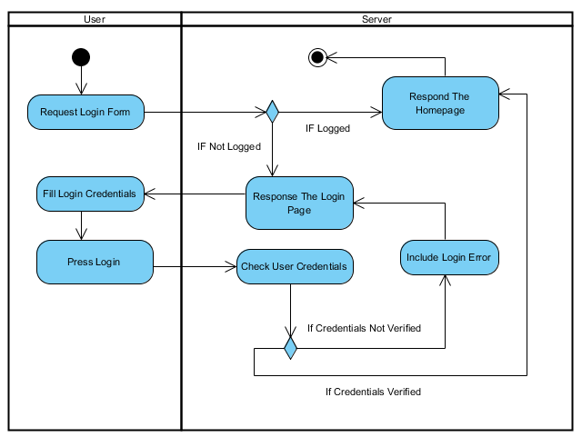

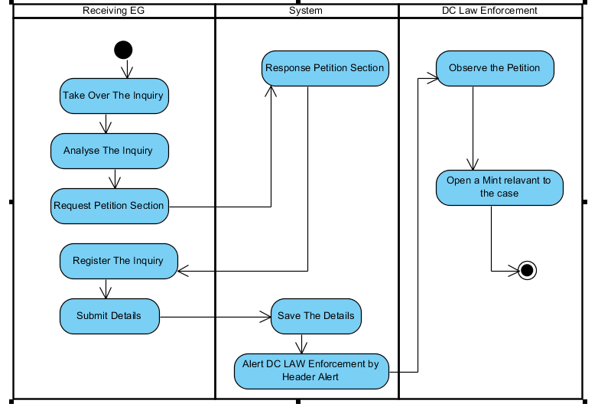 shows Activity diagram for Registering Inquiry

### 3.3.3 Class diagram

This is the nearly all Object-Oriented methods. It describes the structure of a system by showing the system’s classes and relationships among the classes. These classes may be things, peoples or data.

*Class diagram for entire system*

Database design for the system(ER Model)

### 3.3.4 ER diagram - Database design

Data base is more and more important part of the information system. Most of the duties of IS are done by the DBMS. So well normalized data base is nice and essential part of the system.

### 3.3.5. Enhance Entity Relationship Diagram

An enhance entity-relationship model is a systematic way of describing and defining a business process. The process is modeled as entities that are linked with each other by relationships that express the dependencies and requirements between them. Entities may have various attributes that characterize them. Diagrams created to represent these entities, attributes, and relationships graphically are called entity–relationship diagrams.

An EER model is typically implemented as a database. In relational database which stores data in tables, which represent the entities. Some data fields in these tables point to indexes in other tables and these pointers represent the relationships.

aaaaaaaaaaaazzzzzzzzz

aaaaaaaaaaaaaaaaaaaaaaaaa

ddddddddddddddd

## 3.4 User interface design

A user interface which also called a "UI" or simply an "interface," is the means in which a person controls a software application or hardware device. A good user interface provides a "user-friendly" experience, allowing the user to interact with the software or hardware in a natural and easy way.

Nearly all software programs have a graphical user interface, or GUI. This means the program includes graphical controls, which the user can select using a mouse or keyboard. A typical GUI of a software program includes a menu bar, toolbar, windows, buttons, and other controls.

While user interfaces can be designed for either hardware of software, most are a combination of both. For example, to control a software program, you typically need to use a keyboard and mouse, which each have their own user interface. Likewise, to control a digital camera, you may need to navigate

# CHAPTER 04 – IMPLEMENTATION

## 4.1 Implementation environment (hardware/software)

## 4.2 Code and module structure description

## 4.3 Acknowledgement of any reused existing code

# CHAPTER 05 – EVALUATION

To evaluate a project or an activity someone should check or test and verify whether the intended components of the system or the project are full filed satisfactorily, with the specified project activities carried out. The evaluation test should identify the gaps, errors or removing any activity Mentioned in the proposal of Excise Department.

For a software development project, it should be checked whether the system meets the specifications with validations. Whether it has full filed its intended purpose. Verification is process of evaluating software to determine whether the products of a given development phase satisfy the conditions imposed at the start of that phase. Validation checks that the product design satisfies or fits the intended use or the software meets the user requirements.

## 5.1. Test Strategies

The Inventory and Transaction System for the Excise Department was tested following strict test plan in order to ensure the ultimate product is more reliable. Testing was implemented while development progresses going on. Investigation of test cases and test data was carried out following Prototyping.

### 5.1.1. Unit Testing

Unit testing is a method by which individual units of source code, sets of one or more computer program modules together with associated control data, usage procedures and operating procedures are tested to determine if they are fit for use. Most of the cases, the smallest testable part of an application is considered as a unit. In OOP it can be an interface such as a class or an individual method. Unit testing was done while implementing the system to check whether the source codes are accurate and working properly.

5.1.2. Integration Testing

Consolidation of the modules in the system requires the integration testing process to ensure that the combined units also functioning properly and gives the intended results.

Integration testing is carried out after unit testing and before the system validation phase. Integration test plan implements as its test components are pre-tested by unit testing.

### 5.1.3. System Testing

System testing is performed on the entire system in the context of a Functional Requirement Specifications and or a System Requirement Specification. System testing tests not only the design, but also the behavior and even the believed expectations of the department. It is also intended to test up to and beyond the bounds defined in the software and hardware requirements specifications.

As a rule, system testing takes, as its input, all of the "integrated" software components that have passed integration testing and also the software system itself integrated with any applicable hardware systems. The purpose of integration testing is to detect any inconsistencies between the software units that are integrated together (called assemblages) or between any of the assemblages and the hardware. System testing is a more limited type of testing; it seeks to detect defects both within the "inter-assemblages" and also within the system as a whole.

## 5.2. Test plan

The test plan consists of a series of different tests that will fully exercise the Complain Movement Management System for Excise Department of Sri Lanka. The primary purpose of these tests is to uncover the systems limitations and measure its full capabilities. The System tests will focus on the behavior of the Complain Movement Management System for Excise Department of Sri Lanka. User scenarios will be executed against the system as well as screen mapping and error message testing. Overall, the system tests will test the integrated system and verify that it meets the requirements defined in the requirements document. Security tests will determine how secure the Complain Movement Management System for Excise Department of Sri Lanka is. Documentation tests will be conducted to check the accuracy of the user documentation. These tests will ensure that no features are missing, and the contents can be easily understood. Once the Complain Movement Management System for Excise Department is ready for implementation, the company system users will perform User Acceptance Testing.

The purpose of these tests is to confirm that the system is developed according to the specified user requirements and is ready for operational use.

## 5.3 Test Result

#### 5.3.1. Test Cases and Test Results for Login Module

Following table 5.1: shows Test Cases and Test Results for Customer Module

|  |  |  |  |
| --- | --- | --- | --- |
| **Test no** | **Test Description** | **Expected Result** | **Pass or Fail** |
|  |  |  |  |
| 1 | Click the PCMMS button or short cut button | Lord the login form | Pass |
| 2 | Enter the user name given before | If the entered correct user name  nothing happen  else  it is less or excide minimum or maximum number of characters of user name  border of the text area become brown | Pass |
| 3 | Enter the password | If the entered correct password  nothing happen  else  it is less or excide maximum number of characters of password  border of the text area become brown | Pass |
| 4 | Click the login button or enter key | If the both user name and password correct  login page disappears and  fill the Home page  Else  Massage appear “user name or password incorrect try again” and  if it is second chance both ok  Then  Fill the login page  Else  Massage appear “user name or password incorrect try again” and if it is third chance both ok  Fill the login page  Else  Massage appear “user name or password incorrect YOU MUST CALL FOR THE ADMINISTRATOR” |  |
|  |  |  |  |
|  | |  |  |

## 5.4 User Evaluation

# CHAPTER 06 – CONCLUSION

## 6.1 Critical assessment of Project

## 6.2 Future work

In future following features are planning to add to the newly built system as further Improvements.

Enhance this Public Complain Movement System into below tasks.

* Real Time Crime Management
* Technical Crime Management
* Foreign Liquor Consumption Report
* Android System to insert daily updates into the mobile phones

## 6.3. Lesson learnt

As an undergraduate the knowledge gained throughout the project was really valuable. In addition, this gave me an exceptional experience of being in a complete software development life cycle, starting from feasibility studies to conclusion of the project.

This project gave an opportunity to get extensive knowledge on JavaFX, XML, Hibernate, MVC, MySQL, NetBeans and many more languages, tools and technologies. And also it helped to test and implement most important theories and technologies learnt throughout the BIT degree program.

# REFERENCES

# APPENDIX